|  |
| --- |
| CASE STUDY 5 |
| SYSTEM IMPLEMENTATION |
| System Analytics and Design |

|  |
| --- |
| Samrajya Chand  Roll No:30 |

**System Implementation:**

Implementation is the process of building properly working system; install it in the organization, replacing old system and working methods, and finalize system and user documentation and Training end prepared to support the system to assists users. System implementation is made up of many activities. The six major activities are:

1. Coding

2. Testing

3. Installation

4. Documentation

5. Training

6. Support

**Objective/Purpose of Implementation:**

The objectives of implementation are:

1. Converting system design specification into working and reliable software and hardware.

2. Documenting the work that has been accomplished.

3. Providing help for current and future users and system caretakers.

4. Testing the software that has been developed.

**Software Application Testing**

Once coding has begun, the testing process can begin and proceed in parallel. As each program module is produced, it can be tested individually, then as part of a larger program, and then as part of a larger system. We should emphasize that although testing is done during implementation, you must begin planning for testing earlier in the project. Planning involves determining what needs to be tested and collecting test data.

**Seven Different Types of Tests**

Software application testing is an umbrella term that covers several types of tests. Tests can be done with or without executing the code, and they may be manual or automated. Using this framework, we can categorize types of tests as shown in table below:

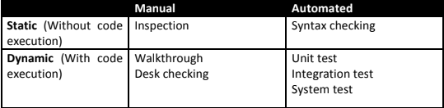

**Inspection:**

Inspections are formal group activities in which participants manually examine code for occurrences of well-known errors.

**Walkthrough:**

In walkthrough, the correctness of the models produced is checked and the errors detected are notified for amendments. Unlike inspections, what the code does is an important question in a walkthrough.

**Desk Checking:**

Desk checking is an informal process where the programmer or someone else who understands the logic of the program works through the code with a paper and pencil.

**Syntax Checking:**

Syntax checking is typically done by a compiler. Errors in syntax are uncovered, but the code is not executed.

**Unit Test:**

Unit testing is sometime called as module or functional testing.

**Integration Test:**

It implies the process of bringing together all of the modules that a program comprises of for testing purpose. Modules are typically integrated in a top-down, incremental fashion.

**System Test:**

It implies the bringing together of all the programs that a system comprises of for testing purpose. Programs are typically integrated in a top-down, incremental fashion. System testing is a similar process, but instead of integrating modules into programs for testing, you integrate programs into systems.

**Acceptance Testing**

Once the system tests have been satisfactorily completed, the system is ready for acceptance testing, which is testing the system in the environment where it will eventually be used. The most complete acceptance testing will include alpha testing, (also called mock client testing), where simulated but typical data are used for system testing; beta testing, in which live data are used in the users’ real working environment; and a system audit conducted by the organization’s internal auditors or by members of the quality assurance group.

**Quality Assurance**

Quality assurance (QA) means carrying out timely checks to ensure that the system being developed meets the quality standards specified. It is necessary to carry out quality assurance checks to make sure that there are no errors in the system and that the system developed meets the original user requirements.

Analysts use four levels of quality assurance: testing, verification, validation, and certification.

Validation: “Are we building the right product?”

Verification: “Are we building the product right?”

Certification: Software certification is an endorsement of the correctness of the program, an issue that is rising in importance for information systems applications.

**Maintenance**

Maintenance is the changes made to a system to fix or enhance its functionality.

Types of Maintenance

There are four types of maintenance:

**Corrective maintenance**: Changes made to a system to repair flaws in its design, coding, or implementation

**Adaptive maintenance**: Changes made to a system to evolve its functionality to changing business needs or technologies

**Perfective maintenance**: Changes made to a system to add new features or to improve performance

**Preventive maintenance**: Changes made to a system to avoid possible future problems

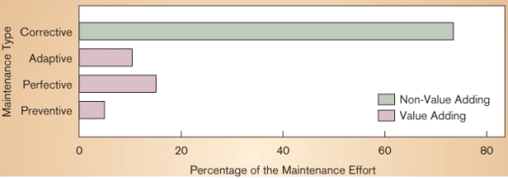

**The Process of Maintaining Information Systems**

It is the process of returning to the beginning of the SDLC and repeating development steps focusing on system change until the change is implemented. Maintenance is the longest phase in the SDLC. Maintenance is like a mini-SDLC.

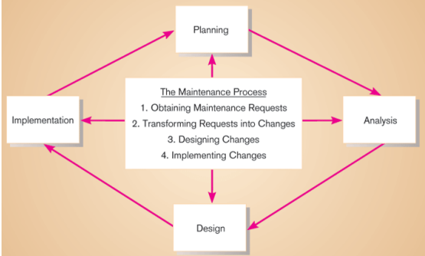

**The Cost of Maintenance**

Information systems maintenance costs are a significant expenditure. For some organizations, as much 60-80 percent of their information systems budget is allocated to maintenance activities.

The factors that influence system maintainability are:

1. Latent defects
2. Number of customers for a given system
3. Quality of system documentation
4. Maintenance personnel
5. Tools
6. Well-structured programs

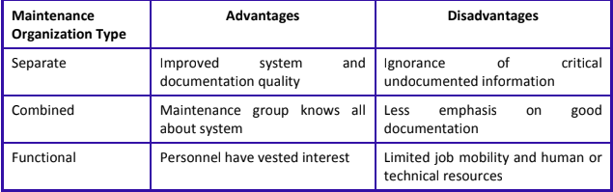

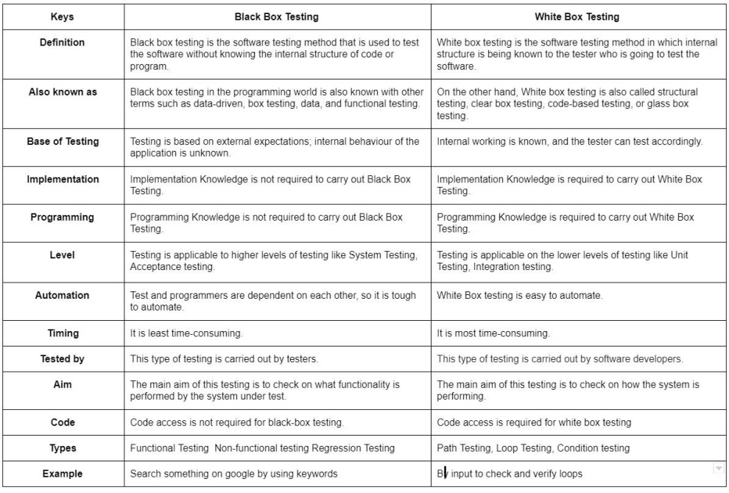

**Installation:**

It is the process during which the current system is replaced by new system. It includes installing the new system in organizational sites as well as dealing with personal and organizational resistance to the change that the new system causes.

Types of Installation:

1. Four installation strategies:
2. Direct Installation
3. Parallel Installation
4. Single-location installation
5. Phased Installation

**Direct Installation**

Changing over from the old information system to a new one by turning off the old system when the new one is turned on

**Parallel Installation**

Running the old information system and the new one at the same time until management decides the old system can be turned off.

**Single location installation**

Trying out an information system at one site and using the experience to decide if and how the new system should be deployed throughout the organization

**Phased Installation**

Changing from the old information system to the new one incrementally, starting with one or a few functional components and then gradually extending the installation to cover the whole new system.

**The Process of Documenting the System, Training Users, and Supporting Users**

**Documentation:**

It is the process of converting software specification with the hard copy format it acts as references maintained for user. It includes reviewing all project dictionary or CASE repository entries for completeness as well as finalizing all user documentation, such as user guides, reference cards and tutorials.

Two audiences for final documentation:

• Information systems personnel (System Builders, internal users) who will maintain the system throughout its productive life.

• People who will use the system (System Users) as part of their daily lives. Documentation **Deliverables: System Documentation, User Documentation**

**A. System documentation**

It is detailed information about a system’s design specifications, its internal workings and its functionality. The intended audience: maintenance programmers. System documentation is of two types:

1. **Internal documentation**: System documentation that is part of the program source code or is generated at compile time
2. **External documentation**: System documentation that includes the outcome of structured diagramming techniques such as data-flow and entity-relationship diagrams

**B. User Documentation**

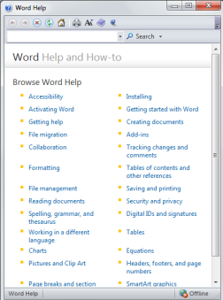 Written or other visual information about an application system, how it works, and how to use it

**Role of Consultant**

For a small firm, an analysis of competitive bids can be confusing. For this reason, the user may wish to contract on outside consultant to do the job. Consultants provide expertise and an objective opinion. A recent survey found, however, that 50 percent of respondent users had an unfavourable experience with the consultants they hired, and 25 percent said they would never hire another consultant. With such findings, a decision to use consultants should be based on careful selection and planning. A rule of thumb is that the larger the acquisition the more serious should be the consideration of using professional help.

